**Coding Assessment Python**

**By Afreen Sultana A**

**Data Cleaning**

**To remove duplicates**

import pandas as pd

data={'Name':['Afreen', 'Dhivakar', 'Priya', None, 'Abinaya','Priya'],'Age':[21, 22, 20, None, 20, 20]}

df=pd.DataFrame(data)

print("Original data:\n", df)

df_unique=df.drop_duplicates()

print("After removing duplicates:\n", df_unique)

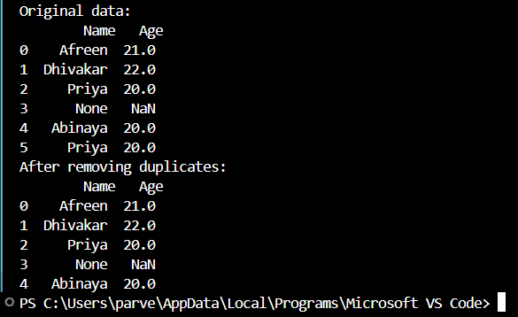

**To remove missing datas**

import pandas as pd

data={'Name':['Afreen', 'Dhivakar', 'Priya', None, 'Abinaya', None],'Age':[21, 22, 20, None, 20, None]}

df=pd.DataFrame(data)

print("Original data:\n", df)

df_cleaned=df.dropna()

print("\nAfter drop:\n",df_cleaned)

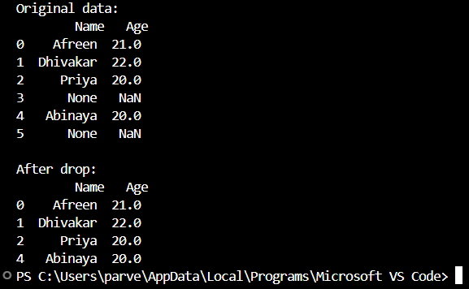

**To replace data**

import pandas as pd

data={'Name':['Afreen','Unknown', 'Zainab'],'City':['Chennai','Unknown','Chennai']}

df=pd.DataFrame(data)

print("Before Replacing:\n",df)

df_replace=df.replace('Unknown','Not Provided')

print("After Replacing:\n",df_replace)

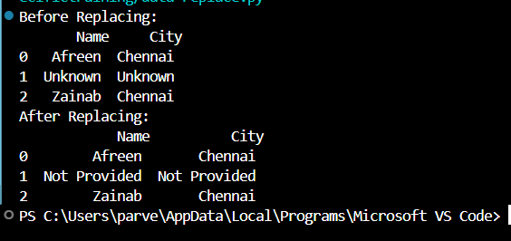

**Joins in Python**

import pandas as pd

Students=pd.DataFrame({'Student_ID':[1,2,3,4,5],'Name':['Afreen', 'Priya','Suganthi','Abi','Zainab']})

Scores=pd.DataFrame({'Student_ID':[1,2,3,6,7],'score':[90,92,86,80,93]})

print("Student Table:\n",Students)

print("Scores Table:\n",Scores)

#inner join

inner_join=pd.merge(Students, Scores, on='Student_ID', how='inner')

print("Inner Join:\n",inner_join)

#left join

left_join=pd.merge(Students, Scores, on='Student_ID', how='left')

print("Left Join:\n",left_join)

#right join

right_join=pd.merge(Students, Scores, on='Student_ID', how='right')

print("Right Join:\n",right_join)

#outer join

outer_join=pd.merge(Students, Scores, on='Student_ID', how='outer')

print("Outer Join:\n",outer_join)

|  |  |
| --- | --- |
|  |  |